DICE

1. Which symbol will be on the face opposite to the face with symbol *?
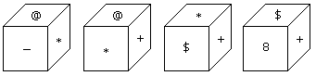

- @
- $
- 8
- +

2. Two positions of dice are shown below. How many points will appear on the opposite to the face containing 5 points?
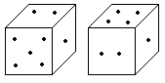

- 3
- 1
- 2
- 4

3. Which digit will appear on the face opposite to the face with number 4?
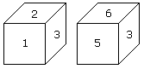

- 3
- 5
- 6
- 2/3

4. Two positions of a dice are shown below. Which number will appear on the face opposite to the face with the number 5?
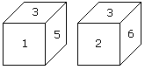

- 2/6
- 2
- 6
- 4

5. How many points will be on the face opposite to in face which contains 2 points?
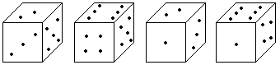

- 1
- 5
- 4
- 6

6. Which number is on the face opposite to 6?

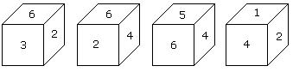

- 4
- 1
- 2
- 3

7. Two positions of a dice are shown below. When number '1' is on the top. What number will be at the bottom?
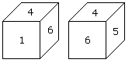

- 3
- 5
- 2
- 6

8. Two positions of a cube with its surfaces numbered are shown below. When the surface 4 touch the bottom, what surface will be on the top?
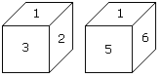

- 1
- 2
- 5
- 6

9. Here two positions of dice are shown. If there are two dots in the bottom, then how many dots will be on the top?
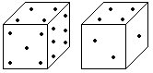

- 2
- 3
- 5
- 6

10. Two positions of dice are shown below. How many points will be on the top when 2 points are at the bottom?
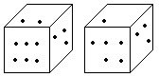

- 6
- 5
- 4
- 1

Answer
- C
- D
- A
- C
- D
- B
- B
- A
- C
- D

